Ionic Compounds
http://www.bbc.co.uk/schools/gcsebitesize/science/add_edexcel/ionic_compounds/ionicanalysisrev1.shtml

Ionic bonds form when a metal reacts with a non-metal. Metals have low electronegativity while non-metals have high electronegativity. The difference in electronegativity’s causes for a transfer of valence electrons from the metal atom the non-metal atom when they come into contact.
Metals form positive ions and non-metals form negative ions when the electron transfer takes place. Because the ions are now in contact and oppositely charged they are held together by the positive-negative attraction. Ionic bonds are the electrostatic forces of attraction between oppositely-charged ions.
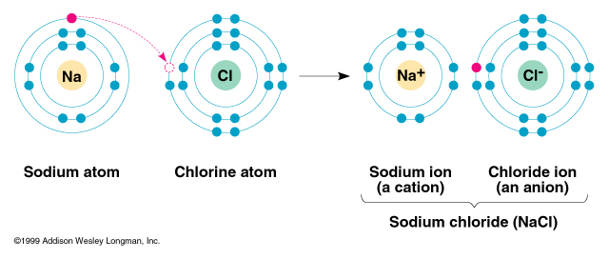

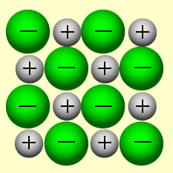
Positively-charged Na ions, negatively-charged Cl ions
Because electrostatic forces are omni-directional, the oppositely-charged ions form giant ionic lattices – not molecules. Ionic compounds will look like crystals as a result of this. The illustration on the left shows part of a sodium chloride (NaCl) ionic lattice.

Properties of ionic compounds
- High melting and boiling points
Ionic bonds are very strong and a lot of energy is needed to break them, so ionic compounds have high melting points and boiling points.
- Conductive when liquid
Ions are charged particles, but ionic compounds can only conduct electricity if their ions are free to move. So ionic compounds do not conduct electricity when they are solid, but they do conduct electricity when they are dissolved in water or when they are melted.
Examples:
Sodium chloride,  NaCl | High melting point - 800°C  Non-conductive in its solid state, but when dissolved in water or molten, NaCl will conduct electricity.

Magnesium oxide,  MgO | Higher melting point than sodium chloride - around 2,800°C. This is because its Mg²⁺ and O²⁻ ions have a greater number of charges, and so form stronger ionic bonds, than the Na⁺ and Cl⁻ ions in sodium chloride.  Because it stays solid at such high temperatures, magnesium oxide remains unconductive, and is used for high-temperature electrical insulation.

